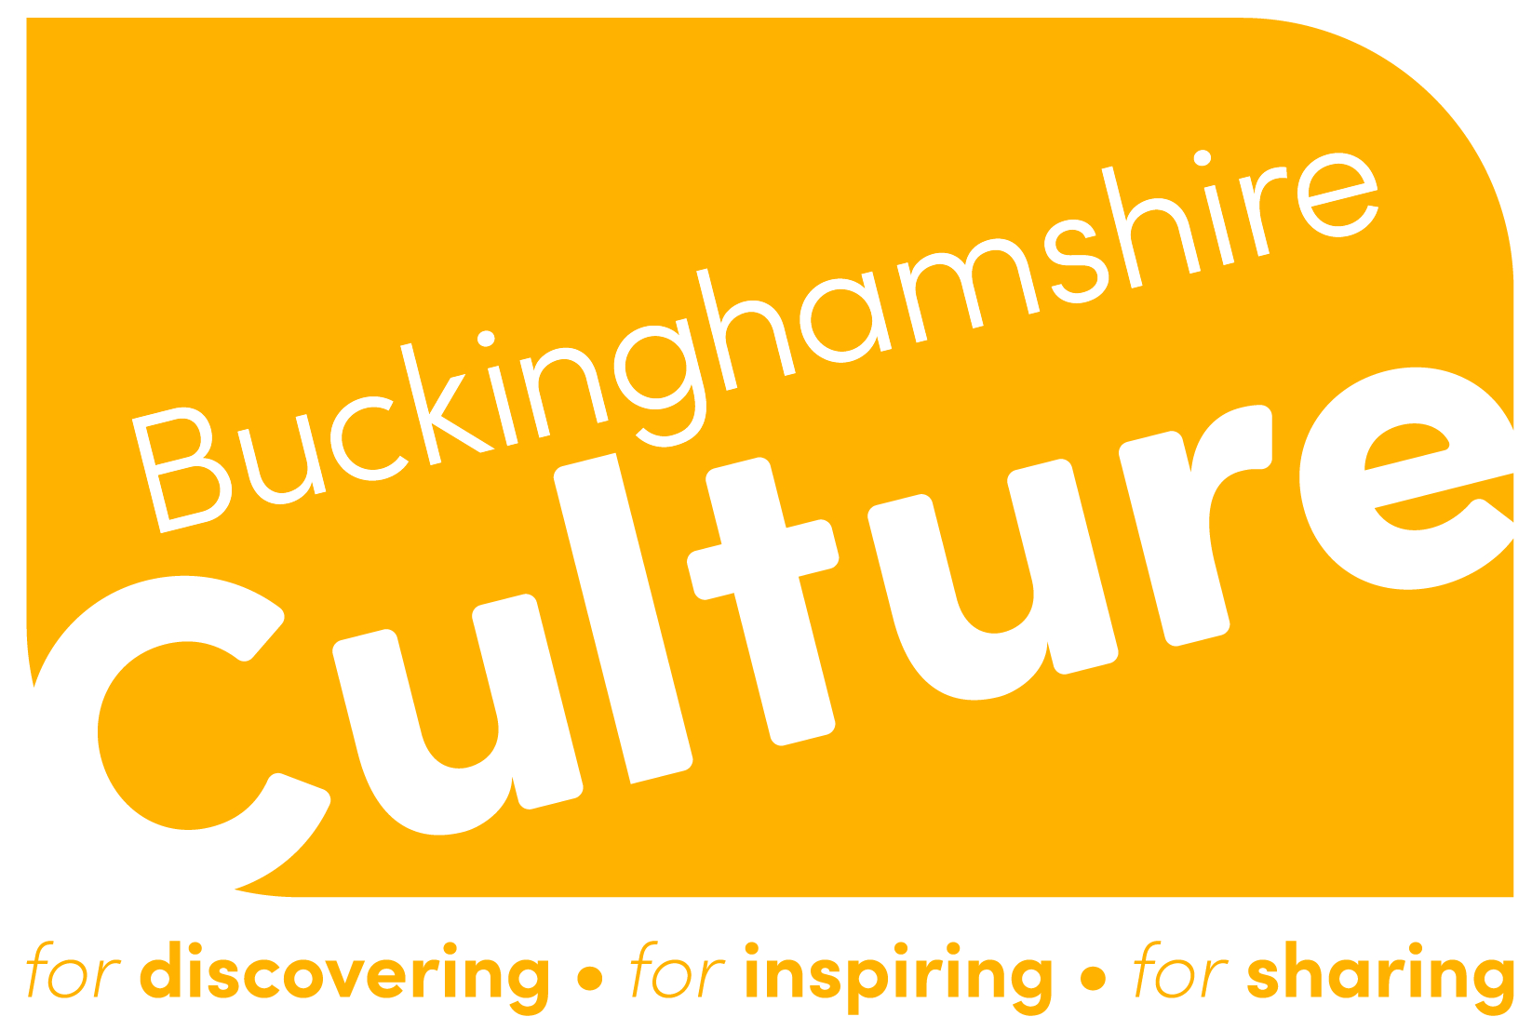
Bucks Spark Awards Application Form

Category: Best Collaboration Award

Application Form Instructions:
• Please complete all sections of this form.
• Fields marked with an asterisk (*) are mandatory.
• You may submit additional supporting documents as specified in the form.
• The word limits for each section are strict; please ensure your responses adhere to them.

1. Collaborative Work Dates Confirmation
Please confirm your collaborative work took place during October 2023 - September 2024.
Collaborative Work Date(s): *
Start Date: _____________ End Date: _____________

2. Collaborative Work Background and Aims* (Maximum 250 words)
Please provide a brief background as to why you ran your collaborative work and what its aims were.
Response:

3. Collaborative Work Description* (Maximum 500 words)
Please provide a detailed description of your collaborative work’s contents. You may also submit up to three photographs to support your answer.
Response:
Photograph Submission (Up to 3):
Photograph 1: [ ]
Photograph 2: [ ]
Photograph 3: [ ]

4. Collaborative Work Impact* (Maximum 500 words)
Please detail the impact of your collaborative work, including data on reach, how you met your objectives, beneficiaries, and value for money. You may also submit up to two photographs to support your answer.
Response:
Photograph Submission (Up to 2):
Photograph 1: [ ]
Photograph 2: [ ]

5. Learning and Reflections* (Maximum 500 words)
Please tell us about any learning for your group or organisation from running the collaborative work.
Response:

Submission Checklist:
☐ Confirmed collaborative work took place between October 2023 - September 2024.
☐ Provided background and aims (250 words).
☐ Provided collaborative work description (500 words).
☐ Submitted up to three photographs supporting the collaborative work description.
☐ Detailed the collaborative work impact (500 words).
☐ Submitted up to two photographs supporting the impact.
☐ Shared learnings from the collaborative work (500 words).

Applicant Information

Name of Organisation/Group:*
Contact Name:*
Email Address:*
Phone Number:*
Postal Address:*

Declaration:
I confirm that all the information provided in this application is true and accurate to the best of my knowledge.
Signature: ______________________ Date: _______________

Submission Instructions:
Please submit this completed form and any supporting documents by the 23rd of September 2024 and send to panagiota@buckinghamshireculture.org. If you have any questions, please contact kerry@buckinghamshireculture.org
Alternative submission option:
Submit an application as a 5 min video uploaded to YouTube answering the questions above.

Thank you for applying for the Bucks Spark Awards - Best Collaborative Work Award.

