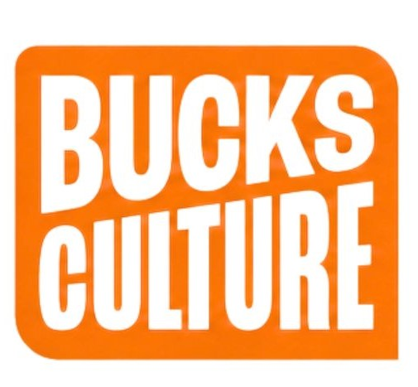
Bucks Spark Awards Application Form

Category: Best Green Project

Application Form Instructions:
• Please complete all sections of this form.
• Fields marked with an asterisk (*) are mandatory.
• You may submit additional supporting documents as specified in the form.
• The word limits for each section are strict; please ensure your responses adhere to them.

1. Event Dates Confirmation
Please confirm your project took place during November 24-September 26.
Event Date(s): *
Start Date: _____________ End Date: _____________

2. Event Background and Aims* (Maximum 250 words)
Please provide a brief background as to why you ran your project and what its aims were.
Response:

3. Event Description* (Maximum 500 words)
Please provide a detailed description of your project’s contents. You may also submit up to three photographs to support your answer.
Response:
Photograph Submission (Up to 3):
Photograph 1: [ ]
Photograph 2: [ ]
Photograph 3: [ ]

4. Event Impact* (Maximum 500 words)
Please detail the impact of your project, including data on reach, how you met your objectives, beneficiaries, and value for money. You may also submit up to two photographs to support your answer.
Response:
Photograph Submission (Up to 2):
Photograph 1: [ ]
Photograph 2: [ ]

5. Learning and Reflections* (Maximum 500 words)
Please tell us about any learning for your group or organisation from running the project.
Response:

Submission Checklist:
☐ Confirmed project took place between November 24-September 26.
☐ Provided background and aims (250 words).
☐ Provided project description (500 words).
☐ Submitted up to three photographs supporting the event description.
☐ Detailed the project impact (500 words).
☐ Submitted up to two photographs supporting the impact.
☐ Shared learnings from the project (500 words).

Applicant Information
Name of Organisation/Group:*
Contact Name:*
Email Address:*
Phone Number:*
Postal Address:*

Declaration:
I confirm that all the information provided in this application is true and accurate to the best of my knowledge.
Signature: ______________________ Date: _______________

Submission Instructions:
Please submit this completed form and any supporting documents by the 24th of September 2026 and send to guy@buckinghamshireculture.org. If you have any questions, please contact kerry@buckinghamshireculture.org
Alternative submission option:
Submit an application as a 5 min video uploaded to YouTube answering the questions above.

Thank you for applying for the Bucks Spark Awards - Best Green Project Award

